# SPL Development Guide for Atom

This development guide will cover using the Atom editor to create and develop applications written in Streams Processing Language (SPL).

If you want to learn about Streams and SPL without downloading and install the Streams runtime, this guide is for you.

To get started with Streams using a local installation, see the Getting Started with the Streams Quick Start Edition page. (/streamsx.documentation/docs/latest/qse-intro)

## Prerequisites

If you are completely new to Streams, read the Quick Start Guide for a basic introduction. Then you can return to this guide to:

* Configure Atom/VSCode for development
* Run a sample application to see Streams in action
* Create your own applications from scratch

Note: This guide will only cover creating Streams applications using SPL. See the Python development guide or the Java development guide to learn about development in those languages.

If you would rather use VSCode, the development guide for that editor is coming soon.

## Table of Contents

* Overview
* Configure Atom
* Get your code into Atom
* Get Familiar With the Editor
* Creating a Streams application from scratch
* Running an application
* Adding a toolkit
* Where to find samples
* Appendix/Troubleshooting

# Overview

Instead of downloading the Streams compiler and runtime to create your applications, you will use the Streaming Analytics service, a cloud based version of Streams. Applications created in Atom are sent to the Streaming Analytics to be compiled and executed.

So, the first step is to create an instance of the service in the IBM Cloud. Visit <https://console.bluemix.net/catalog/services/streaming-analytics> to do so.

# Configure Atom

If you haven’t already done so, download and install Atom.(https://atom.io)

### Set up and download the Streams plugins for Atom:

*atom-ide-ui, ide-ibmstreams, language-ibmstreams-spl, build-ibmstreams*:

* + Go to **Atom** > **Preferences** > **Install** (might be different for Windows)
  + Search for each of the above packages and install it:

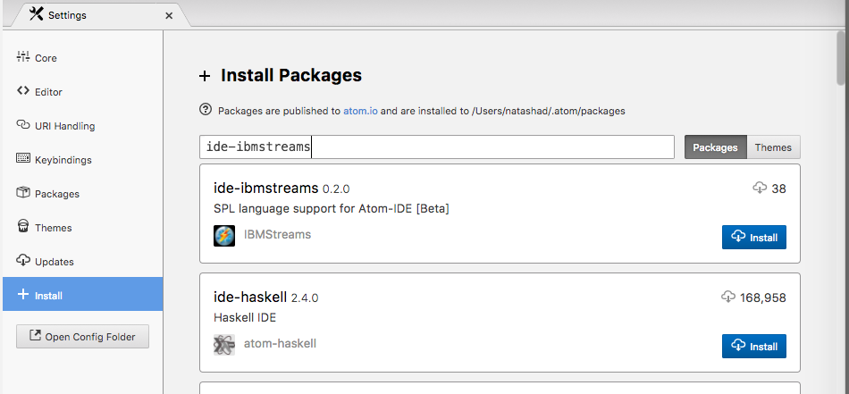

* Install the themes of your choice:
  + **Atom** > **Preferences** > **Install** > **Themes**
  + Search for and install either of *streams-dark-syntax* or *streams-light-syntax*.

#### Add the credentials for your Streaming analytics service:

* + 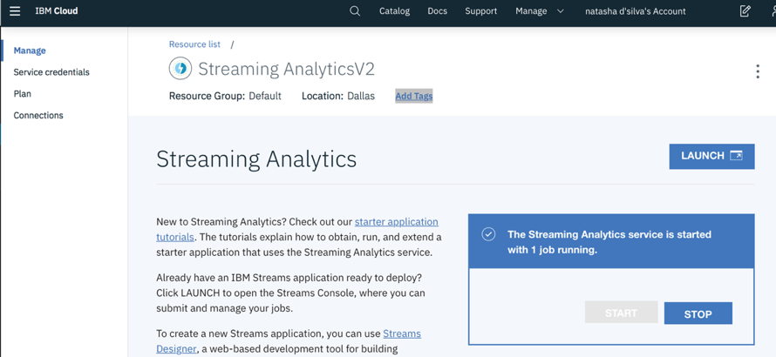From the IBM Cloud dashboard, click the instance of the Streaming Analytics service you created earlier. This will bring you to the service’s main page.
  + Make sure the service is started, if not, click **Start**.
  + Click **Service Credentials** to get the credentials for the service.
    - If there are no credentials listed, click **New Credential** to create one, accepting the defaults.
  + Copy the credentials:

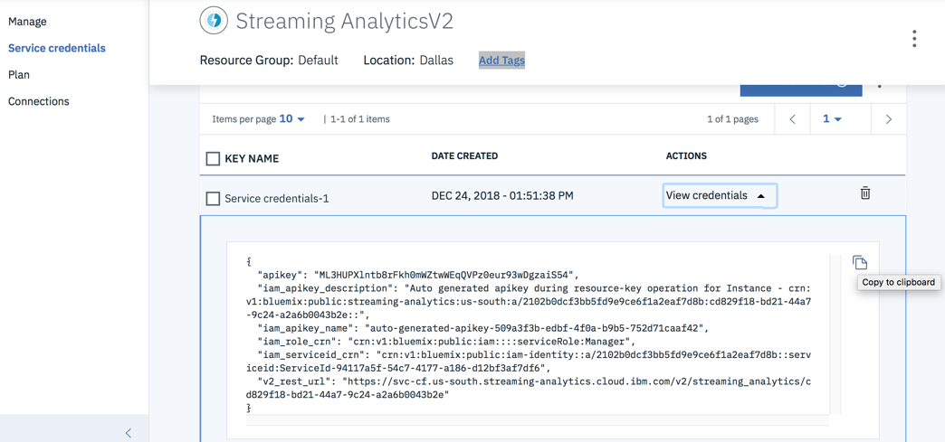

* + Go to **Atom > Preferences > Packages**. Find the **build-ibmstreams** package and click **Settings**.
  + Paste the credentials you copied in to the **Settings** text box.
* Add a toolkits folder:
  + Designate an empty folder on your local filesystem as your toolkits directory. This folder will contain any additional toolkits that provide extra functionality.
  + Go to **Atom > Preferences > Packages**. Find the **ide-ibmstreams** package and click **Settings.** Paste the path to the toolkit directory you just created in the **Toolkits Path** box.

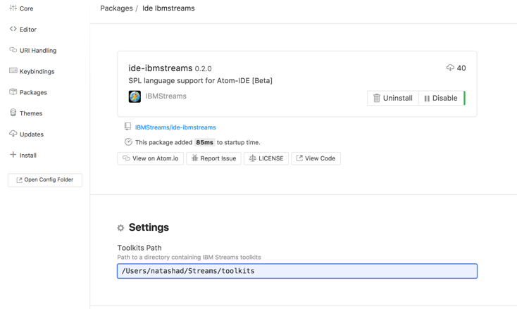

### Migrating from Streams Studio

If you have been using Streams Studio, below you can find links to sections that show you how to import your projects, compile a summary of major differences between Streams Studio and Atom.

* **SPL Projects from Streams Studio** can be used in Atom without having to make any changes. See the Get your Code into Atom section [LINK] for instructions on how to do this.
* **Adding a Streams Toolkit to your workspace** is discussed in the Extending your application with toolkits section below [LINK].
* **The SPL Graphical Editor** is not available, you can view an application’s graph in the Streams Console.
* **Build Configurations** are not used to compile or launch applications from Atom.   
  To compile an SPL composite, you select the SPL file containing the composite, right click, and choose **Build** or **Build and submit Job**.

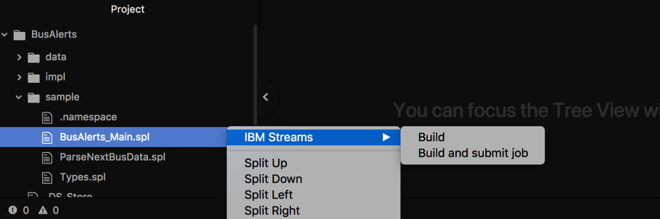

* **Streams Installation, Instance and Domain Management:** SPL Plugins for Atom do not include any Domain or Instance management features because your Streams instance is created and managed in the IBM Cloud. You can manage your Streams instance from the Streaming Analytics Console. Learn more about the Streams Console here. [LINK]
* **Application Monitoring:** Applications launched from Atom are executed on the Streaming Analytics service. Thus, you need to use Streams Console to view metrics, errors, and the Streams graph.

# Get your code into Atom

To get the most out of this guide, it is a good idea to import the sample application.

If you have your own code, you can also jump to the section that best describes your use case:

* Import an existing project (including Streams Studio projects)
* Import a project from GitHub
* Creating a new project in Atom

## Import the sample project for this guide

To follow along with this guide, download the BusAlerts application archive. [LINK]

* Unpack it into a folder
* Import it into Atom: click **File** > **Add Project Folder**. Browse to the project folder and click **Open.**

The following sections describe other ways to start development – importing your own code from a file or GitHub, or creating a new project.

## Import an existing project

The same steps above apply to import any SPL project for use in Atom.

From Atom, click **File** -> **Add Project Folder**. Browse to the project folder, and click **Open.**

## Import A Project From GitHub

If you have existing SPL code on Github**,** you can clone the repository from within Atom:  
From the Command Palette (*CMD + Shift + P* on Mac), type *Github Clone*:

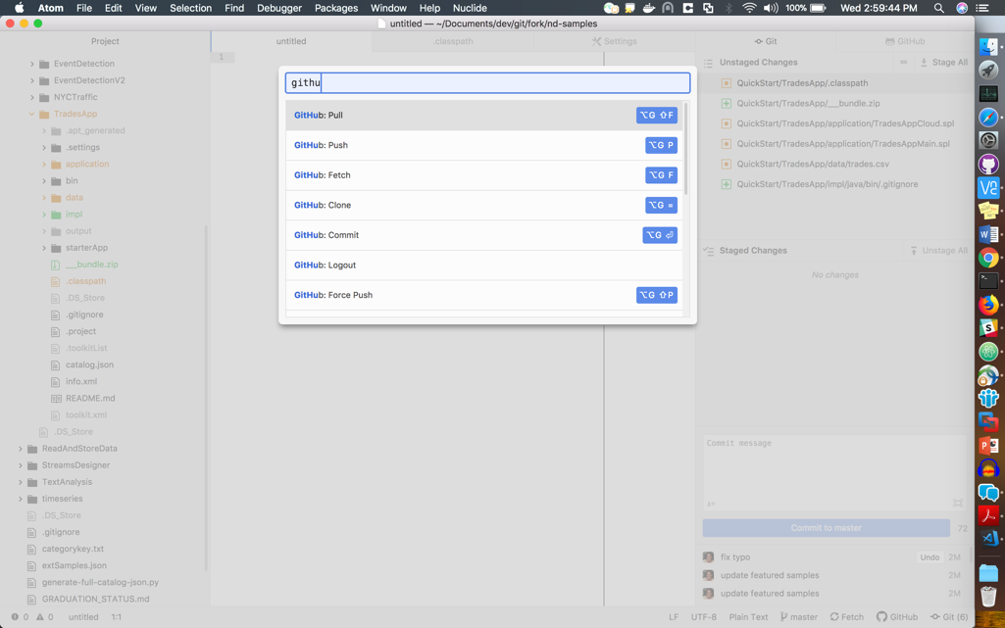

* Then paste the repository URL and click **Clone**.

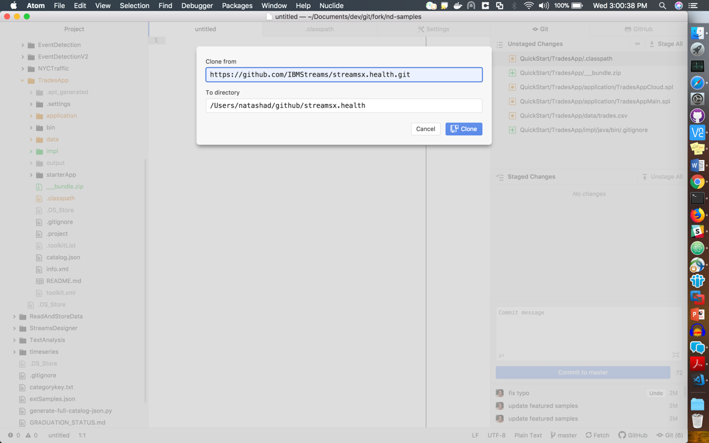

The project should be added to the project pane.

## Creating a new project

To create a new project, you have to create an empty folder and import it into Atom, create the

### Create the project folder

* Create an empty folder on your filesystem, e.g. MyStreamsProject
* From Atom, go to **File** > **Add Project Folder** and select the project folder.

### Create a toolkit information file

SPL projects are also known as toolkits. Each toolkit must have a toolkit information file, info.xml, that describes the project and any other applications/toolkits it depends on. This file must be in the top level of the project.

* Create a file within the folder called info.xml. Right-click the MyStreamsProject folder, select **New File**, and enter info.xml as the file name:

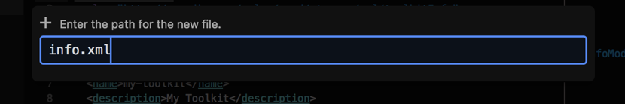

Copy the contents of sampleinfo.xml [LINK] to get you started.

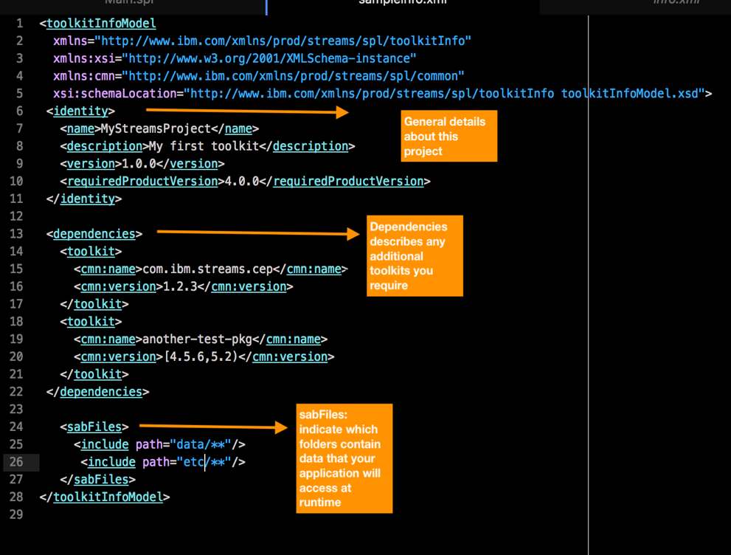

*Sample info.xml file*

Learn more about the information file in the Knowledge Center <https://www.ibm.com/support/knowledgecenter/SSCRJU_4.3.0/com.ibm.streams.dev.doc/doc/toolkitinformationmodelfile.html>

## Create a namespace

Namespaces allow you to organize your SPL code, similar to Python modules or Java packages.

* Create a folder within your project with the target namespace:  
  Select the project, right click, and click **New Folder***.* 
  + Enter a name for the namespace, e.g. my.name.space:  
    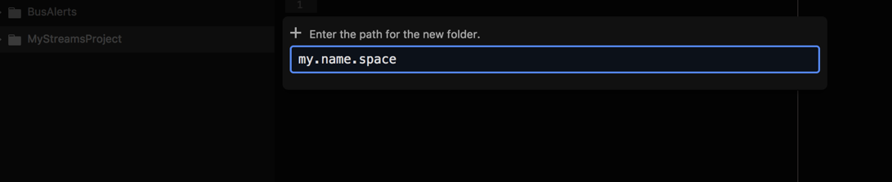
  + Create a new file within the my.name.space folder, call it .namespace

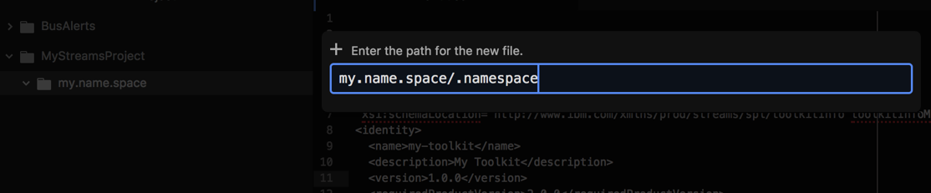

* + The final folder structure should look like this:

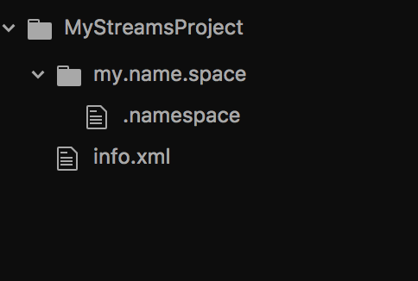

Now that your namespace is created, you can create your first SPL source file.

### Create a SPL source file

A project can have multiple namespaces, and each namespace can have multiple SPL source files. The SPL source file is where you define the application you are creating. They can also contain helper functions.

* Select the “my.name.space” folder, right click > “New File”
* Enter the name for the new SPL file, Main.spl.
* Add the namespace declaration to the file adding the following line to Main.spl:  
  namespace my.name.space;

### Create a main composite

Executable SPL applications are called main composites. Below is a stub for a new executable composite:

composite MyApp {

}

* The final code should appear like this:

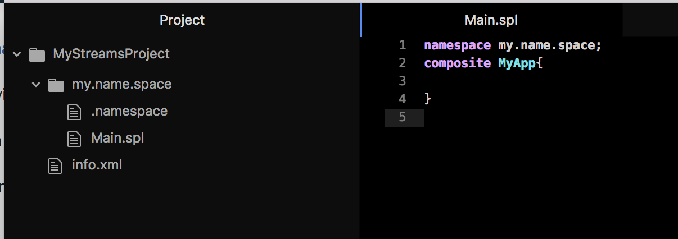

Now you are ready to start development. If you would like some guidance on how to create one please see the designing your streams application section [LINK]

Whether you imported an existing application or are creating one from scratch, it is a good idea to explore the Atom editor to learn about useful editing features.



* If you are looking for a code snippet or sample, try the Streams Samples Catalog (<https://ibmstreams.github.io/samples/>). It contains over 150 sample applications. You can search for SPL only applications by using the languages filter

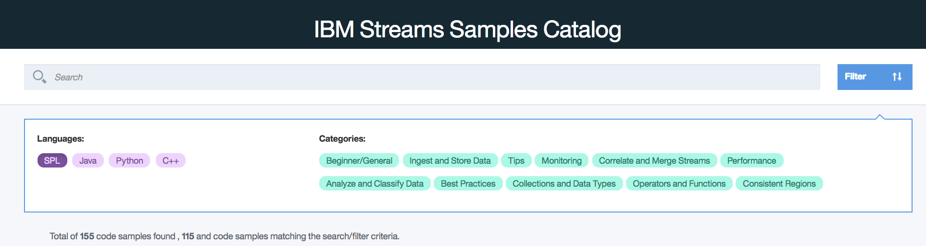

# Get familiar with the Editor

## Atom Overview

Even if you are familiar with SPL, you’ll still want to review this section as it covers some of the SPL features in Atom.

**The Project Pane**

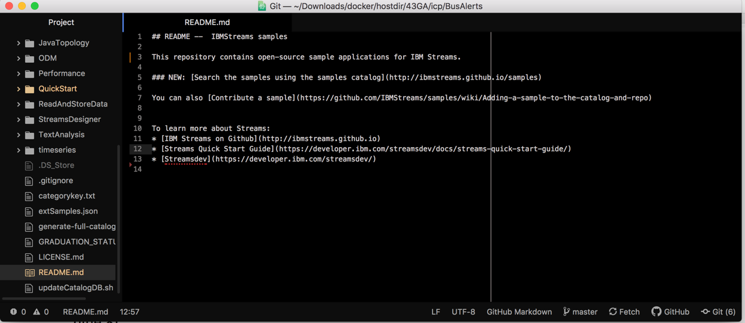

This pane shows the projects you are currently working on. You can have multiple projects open at any time. Use the Add Project Folder option from the File menu to import a project.

**The Command Palette**

Open the command palette (CMD + SHIFT + P) on a mac to see all the available commands. If you are ever unsure of how to do something, search the command palette to see if it is available.

**Version Control with Git**

From the command palette, you can search for *Git or Github tab* and you will be able to open or close these tabs. While the Git tab manages changes in your local repository, the GitHub tab helps you with projects hosted on GitHub.

You can also open the Github and Git tabs from the bottom right of the editor:



From the Git tab, you can view, stage and commit changes you’ve made to your project:

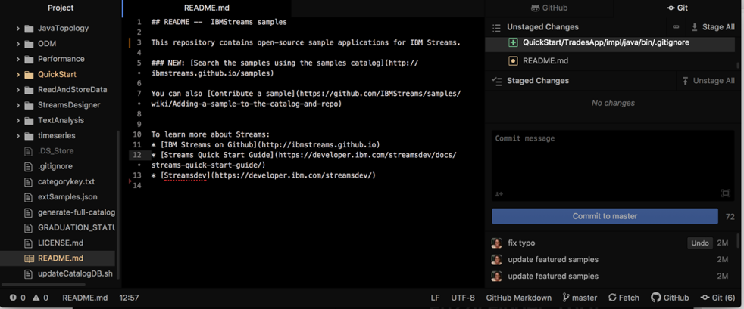

Folders and files that have been changed are also colored differently in the **Project** pane. For example, in the screenshot above, the QuickStart folder and README.md file have both been changed.

See the Atom Flight Manual’s section on Git to learn more about the Git support in Atom.

<https://flight-manual.atom.io/using-atom/sections/github-package/>

## SPL Editing Features

The editor has rich code completion and content assist features.

For example, open sample/Main.spl from the BusAlerts project.

Line 7 contains the line *composite BusAlerts_Main.*

A composite defines either a Streams application or an operator. We will discuss operators later. In this case, the composite *BusAlerts_Main* is the application’s entry point, similar to the class containing the main method in a Java or C++ application.

As is typical of applications, a main composite can be supplied parameters using a ***param*** clause (line 8).

Let’s use this application to explore some Atom features

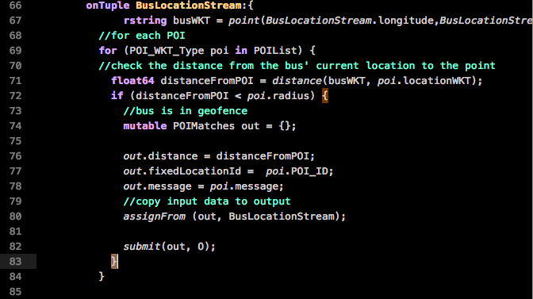

Matching brackets

**Bracket matching** allows you to see the scope of a declaration:

**Code Folding**

If the closing bracket isn’t easily visible, Atom allows you to fold portions of code, as shown below:



Anywhere a downwards caret  occurs, you can collapse the code to make it easier to read.

After defining any needed parameters, a composite must always start with a *graph* clause (line 11).

Everything after the *graph* clause represents the application itself, which is composed of one or more operators.

The first operator in the application is a FileSource operator called BusDataFromFile:

*Output Stream name*

*Operator Kind*

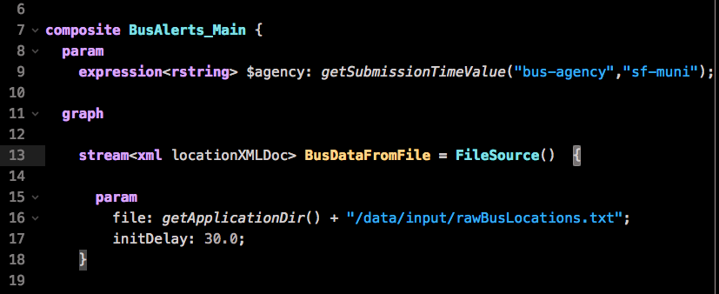

The kind of the operator is a FileSource, but to differentiate between invocations of operators of the same kind, each instance of the operator is called by the name of the output stream. Thus, we refer to this invocation of FileSource as the BusDataFromFile operator.

**View an operator’s documentation**

Hover over the operator name to see its documentation:

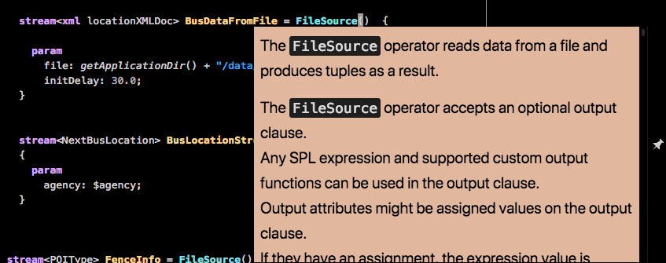

Now that we know the job of a FileSource operator is to read data from a file, the next few lines can be understood:

* + The **param** clause again specifies parameters, but this time for the operator.
    - The file parameter specifies the name of the file.
    - Hover over the initDelay parameter to see what it does.

You can hover over any artifacts, such as parameters, streams, operators, and its documentation will be displayed, if it is available.

**Find References within a File**

As we saw above, the BusDataFromFile operator produces a stream of tuples representing the data that was in the file.

To find out how the BusDataFromFile output stream is used in this application, click on it to highlight occurrences:

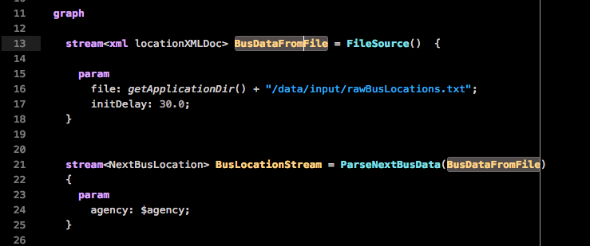

References to that stream are highlighted in grey.

**Find All References Within a Project**

Continuing the example above, the BusDataFromFile stream is used by the ParseNextBusData operator. We can find where this operator is defined by clicking on it, and choosing **Find References** from the context menu.

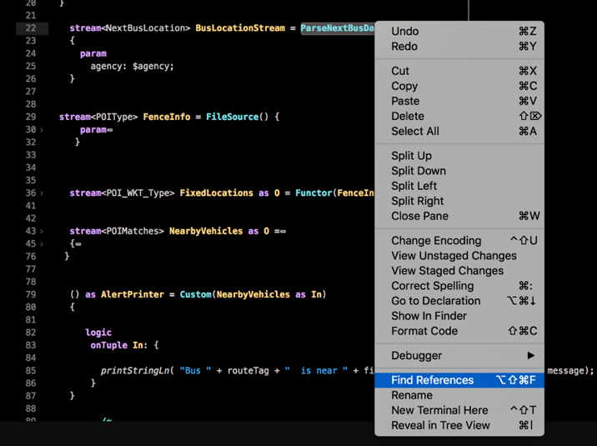

This will show all mentions of this operator, including its definition in another file:

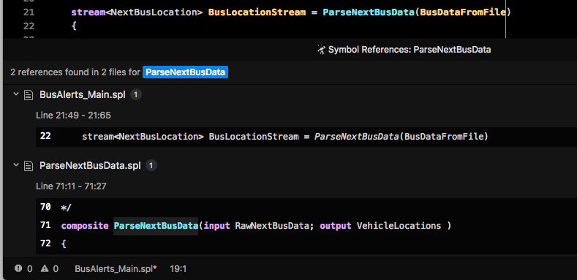

In the **Symbol References pane,** you can click on a result to go to the corresponding file.

**Note:** The **Go to Declaration** menu item is unsupported due to a limitation in Atom.

**Finding problems**

The bottom left corner of the editor will show how many syntax errors are in your code:

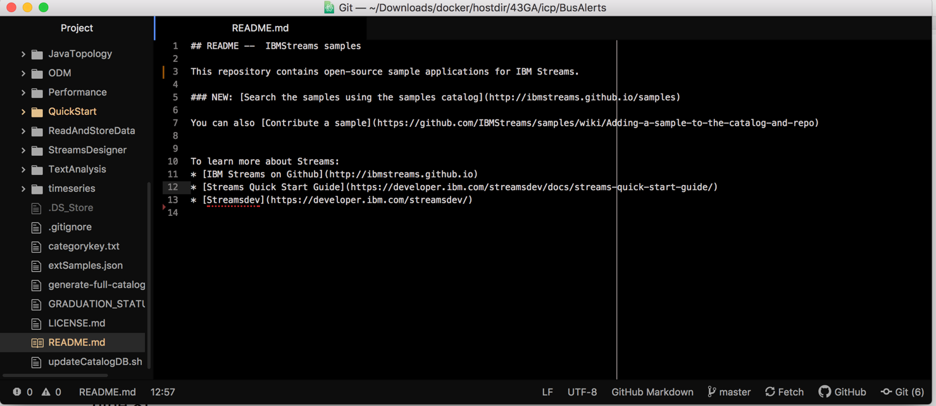Yay, no errors! But if there were, you could click the error icon and it would open the Diagnostics pane to help you find and fix the errors.

You can also open all files with errors at once by typing “diagnostics errors” from the Command Palette:

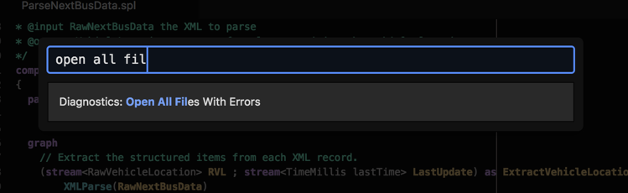

**Code Completion**

The editor also supports code completion to speed up development. As you type, you can hit CTRL+SPACE to bring up a list of suggestions:

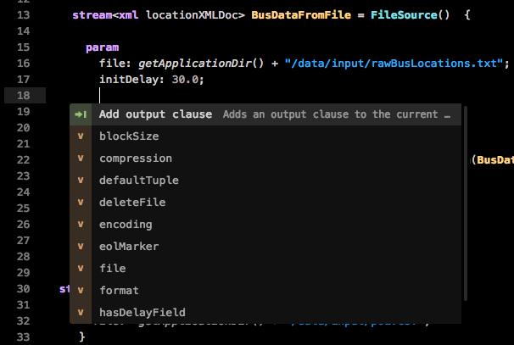

The screenshot above shows the list of parameters available for the FileSource operator.

**Operator Templates**

In addition to suggesting word completions, there is also support for adding code blocks based on templates. Imagine that instead of reading a local file, we wanted to read the contents of a file stored in a Hadoop server on the IBM Analytics Engine. Instead of the FileSource operator, we’d use the HDFS2FileSource operator to read data from Hadoop,.

To add a new HDFS2FileSource operator to our graph, hit CTRL + SPACE on an empty line and search the available operator templates for *hdfs*:

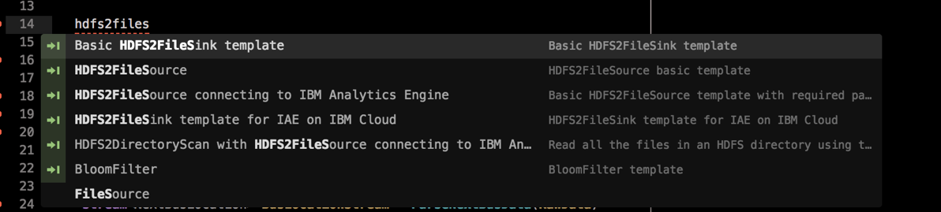

A template exists, so use the down arrows to select *HDFS2FileSource for IBM Analytics Engine* and hit enter:

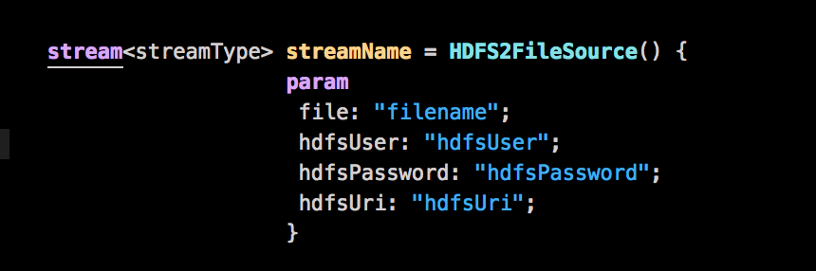

The template for the operator is added to the file, so you would only have to change the operator’s parameters, stream type, and output type to suit your needs.

Remember:

CTRL + SPACE shows code completion suggestions at any time.

ESC dismisses the suggestions that appear.

### Atom Documentation

Additional Information about Atom is available in the documentation:

Atom Basics: <https://flight-manual.atom.io/getting-started/sections/atom-basics/>

Using Atom: https://flight-manual.atom.io/using-atom/

# Run An Application

With the cloud based development using Atom, compilation and execution are all done in the cloud. From Atom, you can compile an SPL using the Build/Build and Submit Job actions:

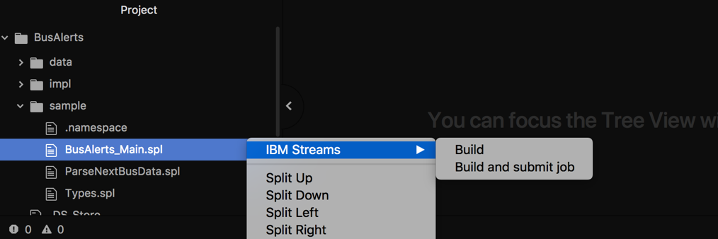

If you choose **Build,** the application will be compiled and the resulting executable (SAB) file will be saved to the output folder of your project. If you choose **Build and submit job**, the SAB file will be sent to the cloud for execution.

Let’s look at an example.

## About The Sample Application

The BusAlerts application is for a city’s transit system. It will display alerts and advertisements within the city’s public transit buses and trains as they move through points of interest.

For example, if there is a security incident along a route, an alert is displayed inside the bus as the bus approaches the region. Also, advertisements for local businesses along a bus’ route will be displayed as the bus approaches the business.

## Build the application

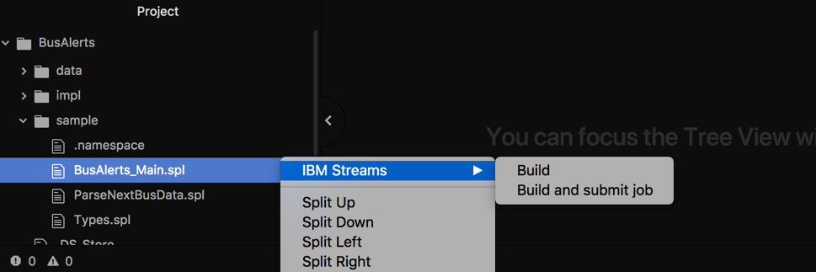In the **Project** pane, select the SPL file containing the composite you want to run. In our example, select BusAlerts->sample->Main.spl. Right click, and select IBM Streams -> Build and Submit job*.*

Various alerts describing the progress of compilation will pop up:

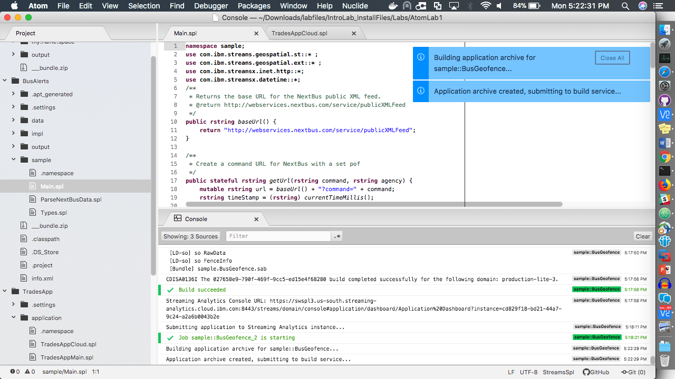

## View Compile Messages and Errors in the Console Pane

The Console pane contains all information and error messages received from the Streaming Analytics service. Check this pane to view details of any errors that may occur during compilation.

Click **View > Toggle Console** and the console pane will appear:

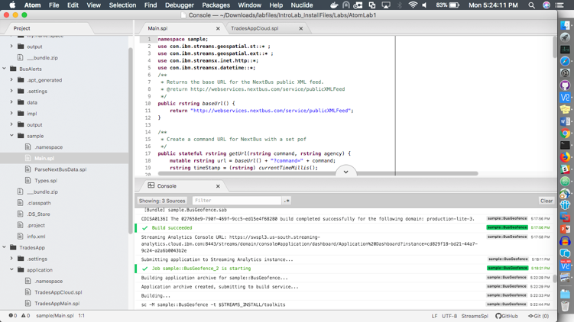

If an error occurs, see the Troubleshooting section for help to resolve errors.

## Run the application

If you compiled using Build and Submit Job, you will receive an alert once compilation is successful:

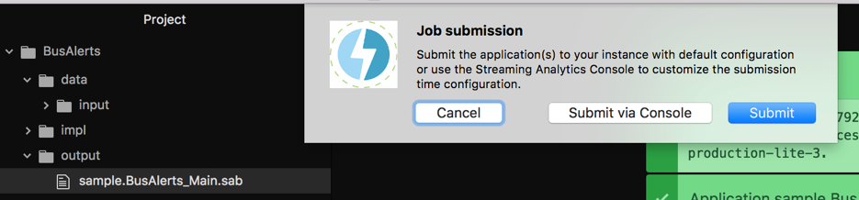

*Submitting the job* means running the application on the Streaming analytics service.

Click *Submit* and the application will be launched for you. We will come back to the *Submit via Console* option later.

## View the running application in the Streams Console

Once the application is launched, you will be prompted to view the application in the Streams Console.

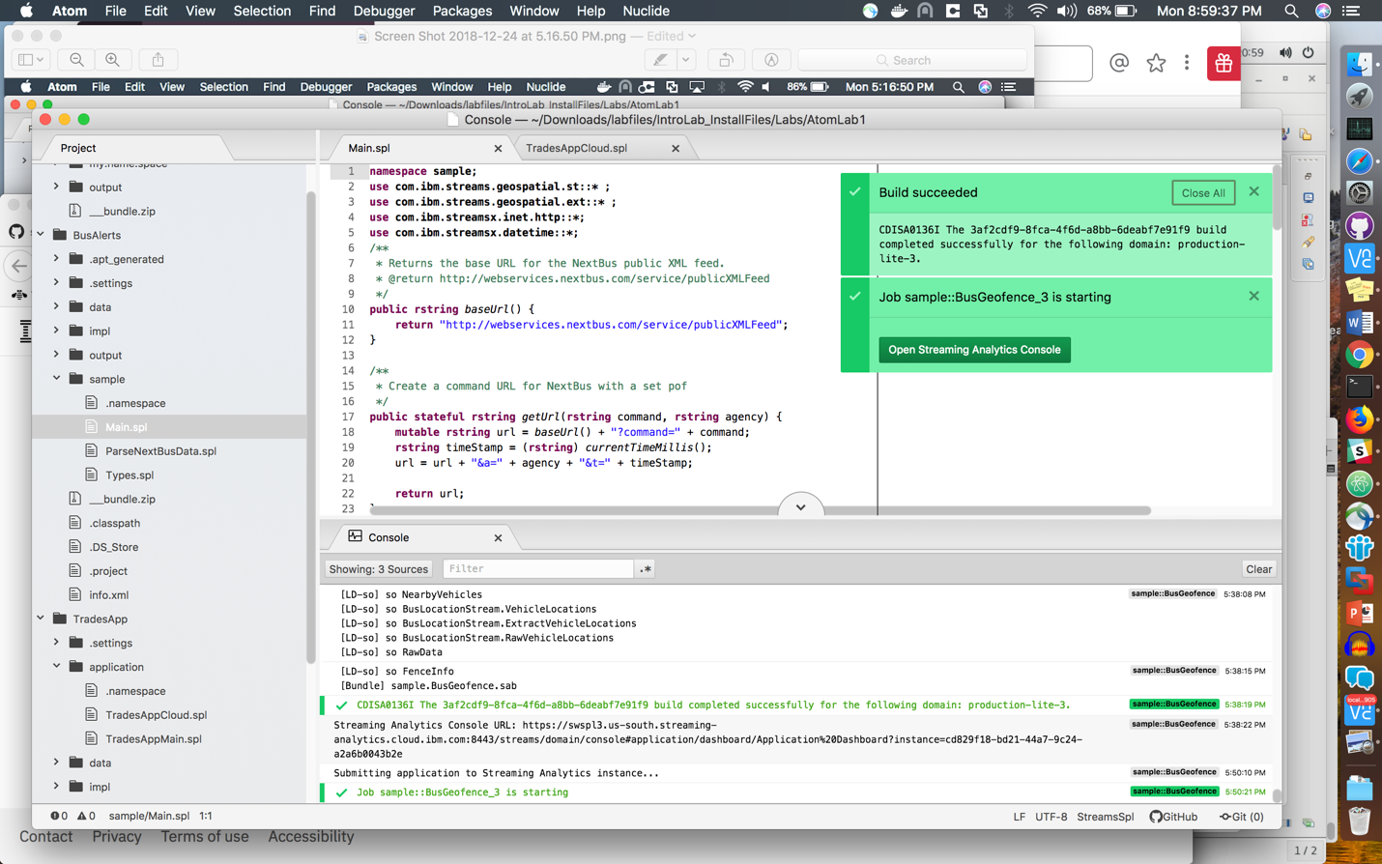

Clicking *Open Streaming Analytics Console* will open the console in your browser.

## Streams Console Overview

You can manage and observe your running applications from the Streams Console. You can start, restart and stop applications here, view log data, and observe metrics such as throughput.

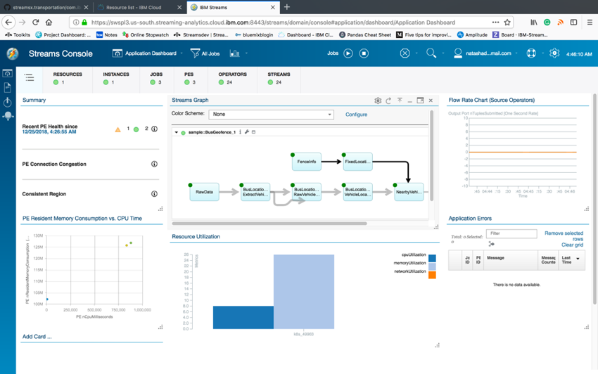

### Viewing the Application’s Logs

Let’s start by looking at the output of the application. Recall that our application monitors buses and will send an alert if a bus is near a business with an ad or an area with an alert. The application is simple so whenever it detects that a bus should be receiving an alert, it just prints the alerts for now. We can take a look at the output by going to the Log Viewer, which is opened from the far left:

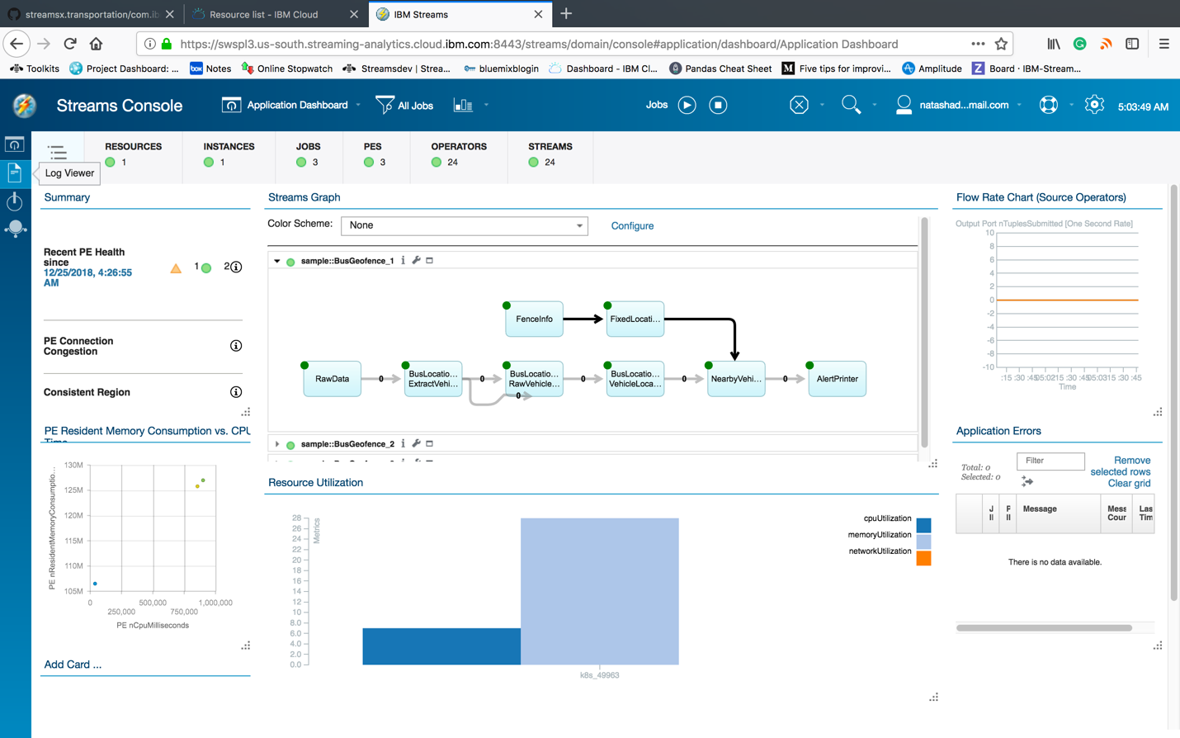

Then, expand the application, select the *AlertPrinter* operator, and click **Console Log**.

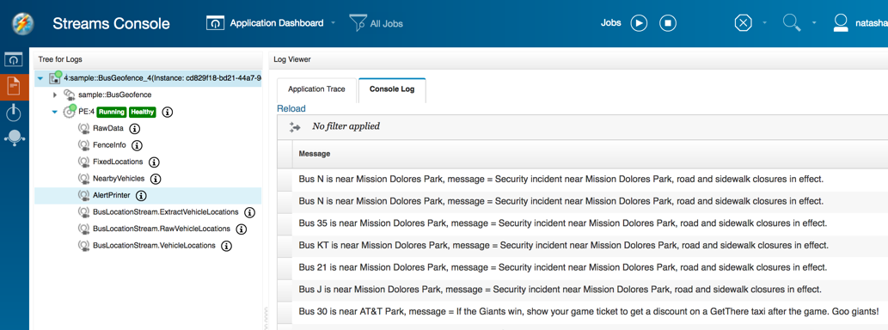

Each line indicates the bus route, the business or area of interest, and the message that would be sent. For example, the first message would be to the N bus, stating that there is a security incident near Mission Dolores Park.

## Launching an application with parameters

So far we submitted an application for execution without setting any parameters at runtime.

This section will show how to provide parameters to an application right before submission.

Our application has been monitoring buses in the San Francisco Municipality. We can change it to monitor buses in a different region, e.g. Toronto, simply by changing the bus-agency parameter.

If you have an application and would like to specify a parameter at runtime, you cannot submit the application from Atom after compilation. The application must be submitted through the Streams Console.

If you try to submit a job and get this message:

CDISR1146E The following job submission parameter is required, but it is missing: sample::BusAlerts_Main.bus-agency.

Or this prompt:

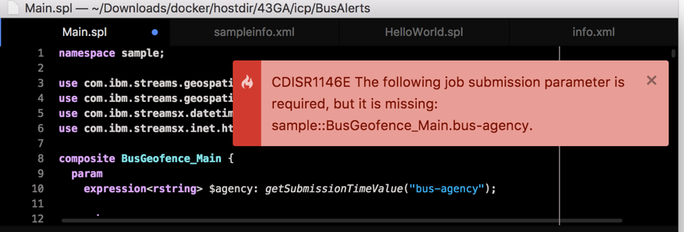

It means you need to recompile the application and submit it via the Streams Console.

Select the SPL file, right click and click **Build**



This will compile the application and save the executable file within the output folder of your project.

If the build is successful, you will see a new folder within the project containing the executable file:

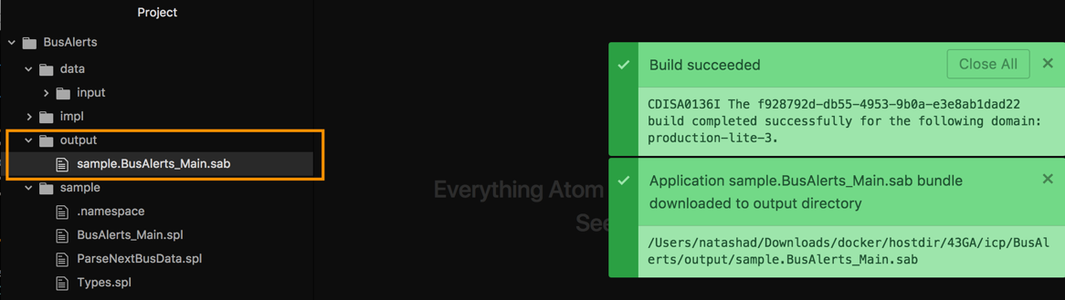

To launch the application, you can select the SAB file from the output folder and click Submit Job.

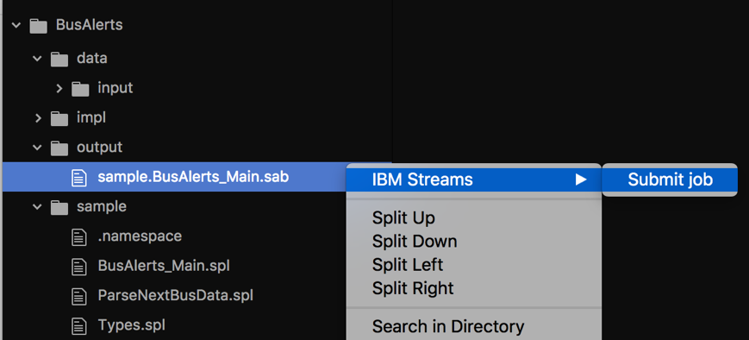

You will again be prompted to submit the application, but this time choose “Submit via Console”

**

This will open the Streams Console in your browser.

From the Console, click the Play button to submit a job.

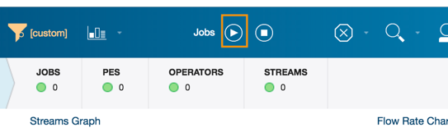

Click **Browse** in the dialog that pops up, to select the SAB file from the output folder of your project.

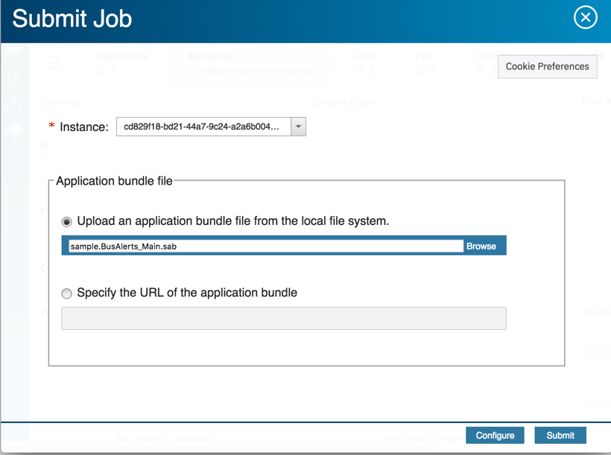

(Tip: the path to the file is printed in the Atom Console, so you can copy and paste it)

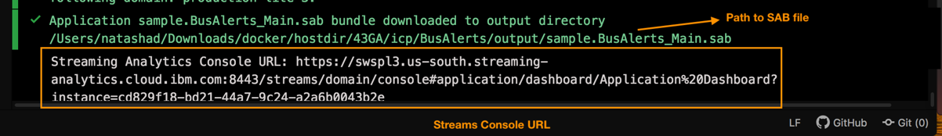

Click Submit. You will be prompted to set parameters:

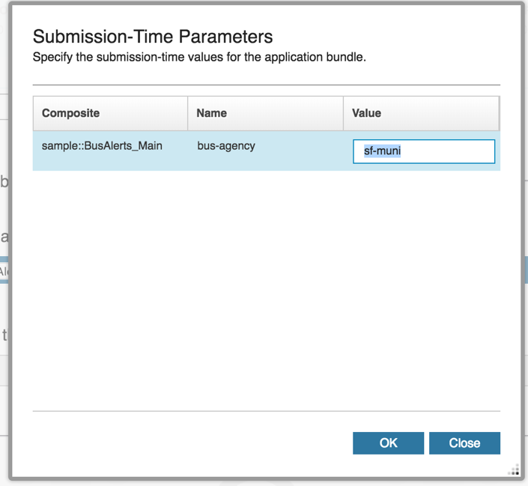

Here we are prompted with a list of all the application’s parameters. Change the values as you would like. For example, changing the bus-agency to *ttc* (Toronto Transit Commission) will cause this application to monitor buses in Toronto.

In the code, this list corresponds to the list of attributes in the **param** clause:

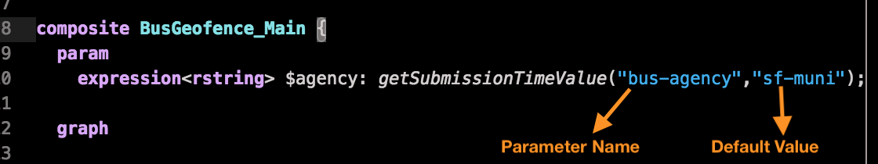

This application has one named parameter, bus-agency, whose default value is sf-muni(San Francisco Municipality).

Application parameters are also called submission time values, because they are specified at submission time. The getSubmissionTimeValue function returns the user-specified value of a named parameter.

Tip: If there is no default value for a parameter, invoke getSubmissionTimeValue with only one parameter:

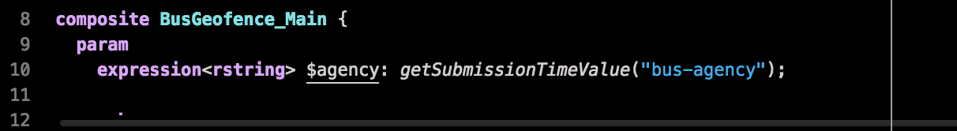

### Submission Time Values

Application parameters are also called submission time values, because they are specified at submission time. The getSubmissionTimeValue function returns the user-specified value of a named parameter.

This application has one named parameter, bus-agency:



getSubmissionTimeValue will return the value that you specified for the bus-agency parameter at submission time, or the default if the value was specified.

The bus-agency allows you to set id of the municipality that we are monitoring.

The default is set to sf-muni, which stands for San Francisco Municipality. So, the application we just launched is monitoring buses in the San Francisco region. If we change the parameter, it would start to monitor buses in a different region.

Select BusAlerts_Main.spl in the Project pane, right click and choose IBM Streams > Build :

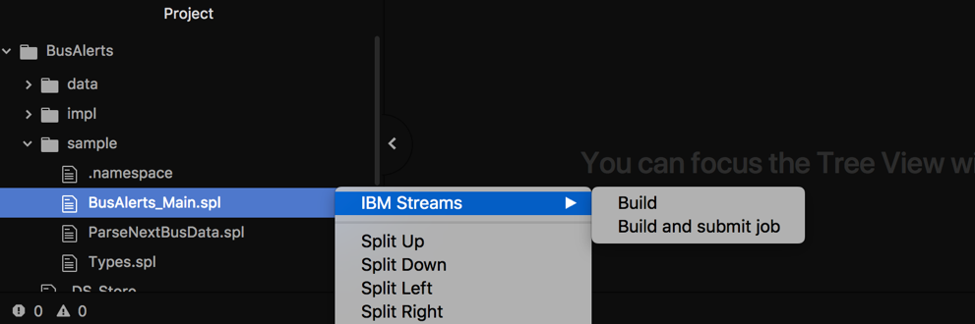

## Build vs. Build and Submit Job

To build an application, you must first compile it: Right click the SPL file and choose **IBM Streams > Build** or **IBM Streams > Build and Submit Job.**

**Build** and **Build and Submit Job** will both send the code to the service for compilation.

* + - Use **Build** to compile the application and save the executable file, called a SAB file, to your project.

This allows you to submit the application manually.

You need to submit the application manually when you want to specify a parameter at submission time.

Having the executable file saved locally also means you can relaunch the application whenever you need to, assuming you have not made any changes to the code. Of course, if you have changed the code, you will need to recompile.

* + - Use **Build and Submit Job** to compile and submit the application for you. It does not download the executable SAB file to the local project.

Now that we have our application running, let’s take a closer look at it. From the Log Viewer, you can return to the main dashboard by clicking Application Dashboard > Open Dashboard > Application Dashboard.

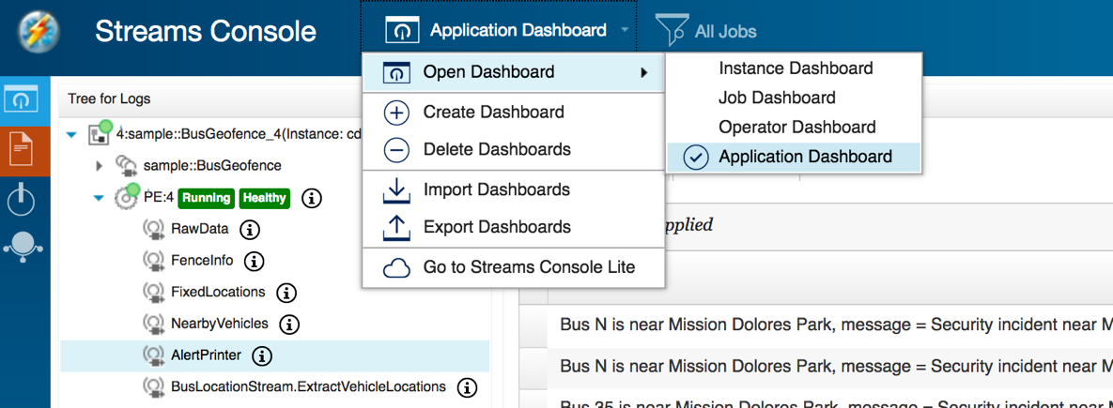

## Understanding operators

The **Streams Graph** in the Console provides a visual representation of each application that is running. Taking a closer look at this visualization will help you understand your application’s layout and design.

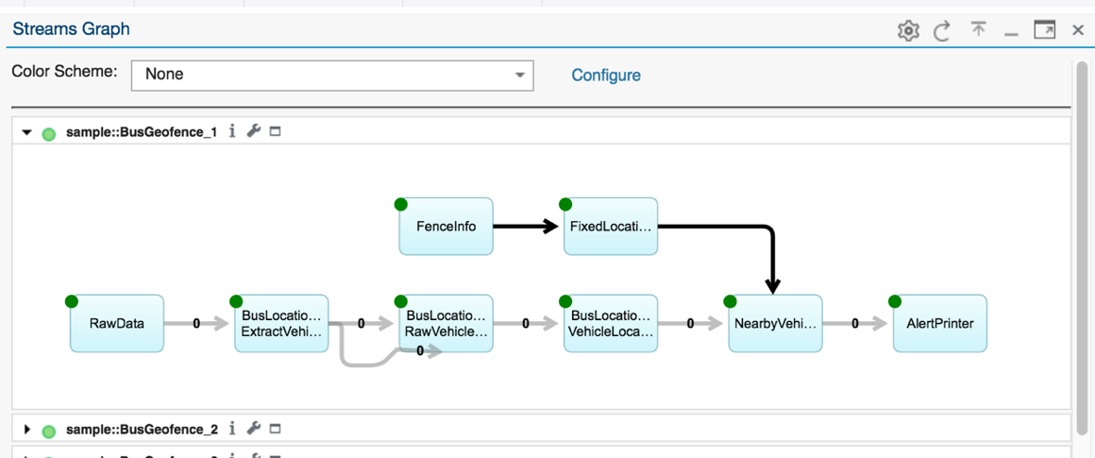

Input stream

Output stream

Operator

Each rectangle in the graph is an **operator**, and each arrow between operators is called a **stream.**  Each stream is data flowing into or out of an operator.

You might recognize the first node in the graph, the *BusDataFromFile* operator, which was an instance of a FileSource:

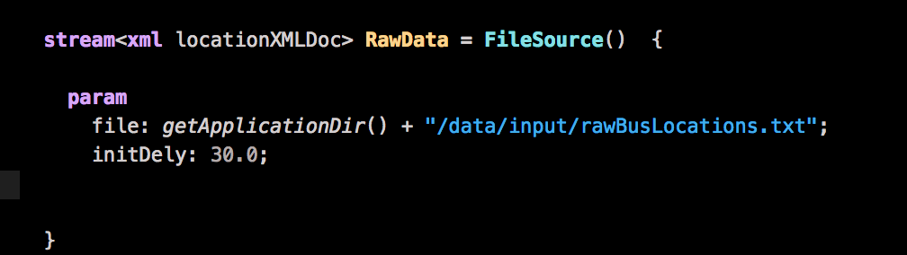

You will notice that the BusDataFromFile operator only has an outgoing arrow and does not have an incoming arrow. This means it does not receive any incoming data but only produces output. Operators of this kind are called *source* operators. Although there are dozens, if not hundreds of operators available in streams, there are only 3 types:

An operator can be:

- a source operator, meaning it produces data for processing and does not take any input,

- a processing operator that accepts incoming data, performs some kind of processing on the incoming data, and forwards it to the next operator for more processing/analytics,

- or a sink operator, which saves incoming data and does not produce any output.

Looking again at the graph, this application has 2 source operators, *BusDataFromFile*  and *FenceInfo*, and 1 sink operator, *AlertPrinter*. The remaining operators in between perform some processing.

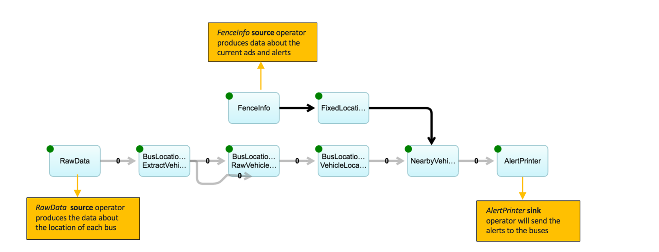

Source/sink operators usually access external systems to read or write data. The external systems could be a file, a database, messaging system such as Kafka, raw TCP packets, HDFS (Hadoop File System), and many more.

So far, the data about the buses’ locations has been coming from a file.

The next step will be to change the application so that the data is no longer from a file but from the live data feed provided by NextBus.

## Stop a running application

Once you are finished with an application, stop it by clicking the **Cancel** button from anywhere in the Streams console:



Select the jobs to be cancelled and click Cancel Jobs:

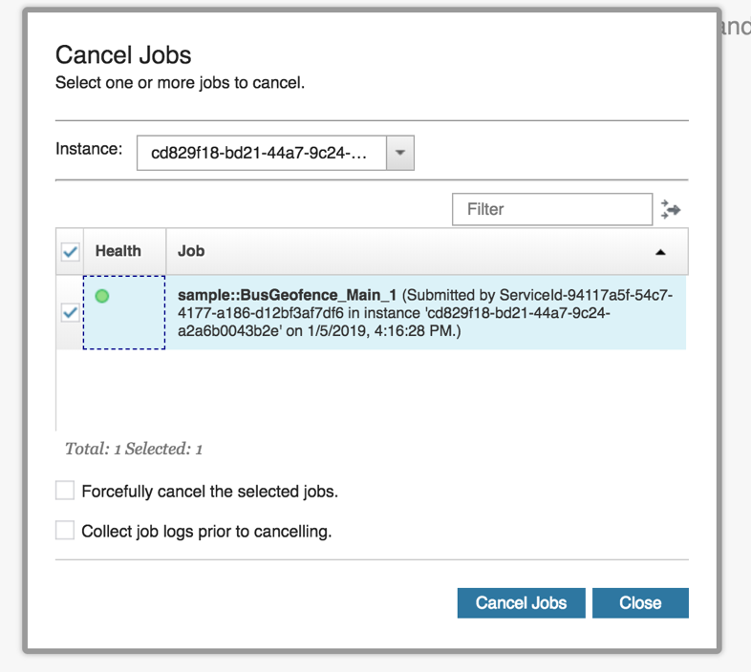

**Avoid leaving an application running on the Streaming Analytics service so that you do not exceed the free computation limit and/or incur additional charges.**

# Extending your application with toolkits

## What is a toolkit?

The Streams runtime includes many operators which provide a wide variety of functionality. Operators, in turn, are grouped by function into toolkits. For instance, the operators used to connect to Kafka are in the Kafka Toolkit.

Sometimes you need to add a toolkit that isn’t already included in Streams, such as one of the many open source toolkits available on GitHub[link]. Or, you might wish to use an updated version of an existing toolkit instead of the one included in the Streams runtime.

## How to add a toolkit for development

The general steps are:

* Download the toolkit,
* Place it in the Toolkits Directory you created when you configured Atom,
* Add a dependency to the toolkit in your project’s info.xml file.

Then the toolkit’s operators and functions are ready for use within Atom.

Let’s walk through an example.

## Adding a toolkit example: extending the BusAlerts application to use live data

To retrieve live bus locations from the NextBus service, we need to use the HTTPGetXMLContent operator from the inet toolkit.

The inet toolkit is included in Streams but we will download the latest version from Github:

1. Download and unpack the toolkit:
   1. Go to <https://github.com/IBMStreams/streamsx.inet/releases>
   2. Download version 3.0 or greater: streamsx.inet.toolkit-3.0.0-**el7-amd64**

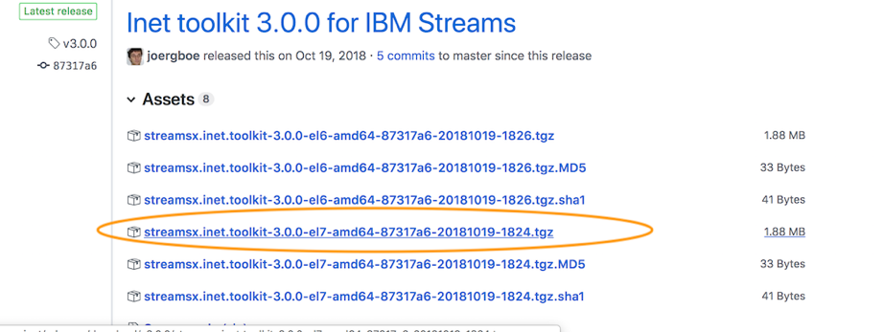

**Note**: Some toolkits have platform dependent features that require multiple platform dependent releases. If the toolkit you wish to use has multiple releases for different platforms, make sure to choose the el7-amd64 release. This is the release that is compatible with the Streaming Analytics service.

1. Place the toolkit in the toolkits directory:

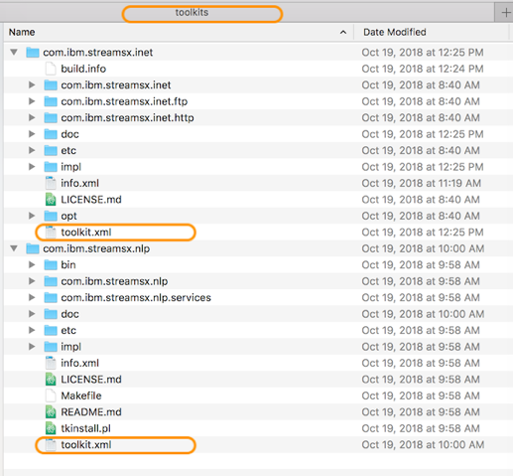

When you copy a toolkit to the toolkit directory, make sure that there is a toolkit.xml file is present at the top level of the folder, as shown above. I have two toolkits, com.ibm.streamsx.inet and com.ibm.streamsx.nlp, and both have a toolkit.xml file.

1. Add a dependency to the com.ibm.streamsx.inet toolkit to your project:
   1. Open the info.xml file of your project, in this case BusAlerts/info.xml. If your project does not have an info.xml file, create one using the sample [HERE]
   2. Add a dependency to the com.ibm.streamsx.inet toolkit by editing the dependencies node:

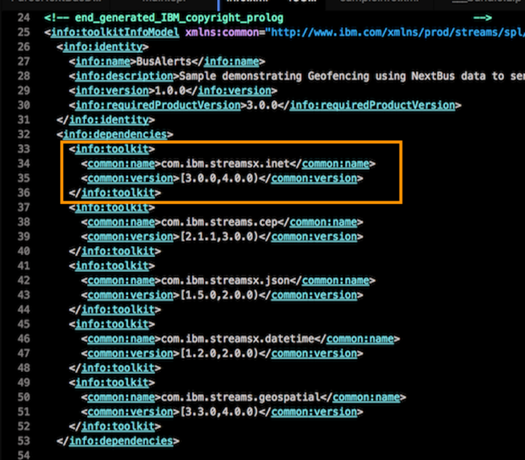

Here is a snippet for you to paste:

<info:toolkit>

<common:name>com.ibm.streamsx.inet</common:name>

<common:version>[3.0.0,4.0.0)</common:version>

</info:toolkit>

After saving the info.xml file, the com.ibm.streamsx.inet toolkit is ready for use in our application.

Go back to Main.spl.

We’re going to replace the BusDataFromFile operator which is a FileSource, with a HTTPGetXMLContext operator from the inet toolkit.

1. Import the operator with a **use** directive:

At the top of Main.spl, type:

use com.ibm.streamsx.inet.http::HTTPGetXMLContent;

1. Highlight the operator’s definition and then click Edit > Toggle Comment:  
   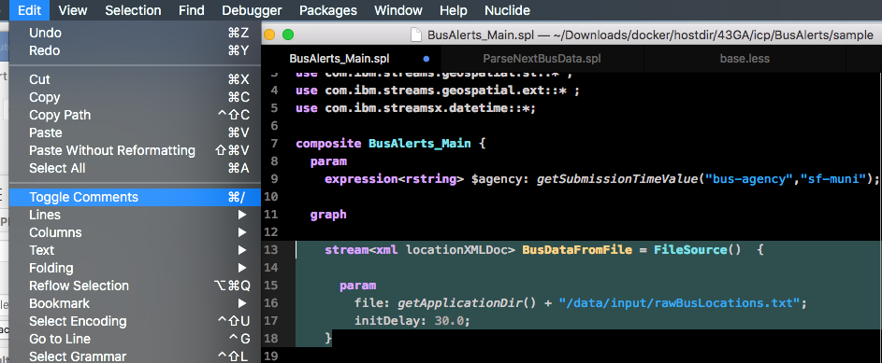
2. Paste the following snippet in the editor:

stream<xml locationXMLDoc> RawData_Live = HTTPGetXMLContent()

{

param

url : getUrl("vehicleLocations", $agency);

period : 30.0; //poll every 30 seconds

updateParameter: "t";

updateParameterFromContent: "/body/lastTime/@time";

}

1. Change the BusLocationStream operator to use the RawData_Live stream instead of the RawData stream:

Change the line:

stream<NextBusLocation> BusLocationStream = ParseNextBusData(RawData)

to:

stream<NextBusLocation> BusLocationStream = ParseNextBusData(RawData_Live)

1. Save the application.

We’ve now replaced the operator that was reading from a file with one that will connect directly to NextBus. Try it out by selecting Main.spl > Build and submit job.

After the build succeeds, verify it is working by opening the Streaming Analytics console, wait a minute or 2 for the application to connect, and then checking the Log Viewer again:

## Adding a toolkit: full steps

1. Toolkits must be built, meaning that the top level of the toolkit must have a toolkit.xml file.
   1. If you are downloading a toolkit from GitHub, a built version of the toolkit is available from the releases page of the GitHub project. If there are releases for different operating systems, choose the EL7-AMD64 build.
   2. If no release exists, or if the downloaded release does not include a toolkit.xml file, see the toolkit’s page for instructions on building it.
2. Put the toolkit folder into the toolkit directory you created during the initial setup[LINK]. Recall that you specified this path in the **ide-ibmstreams** package settings.
3. Create a toolkit information file, called info.xml for your project, if it does not already have one. This file describes your project and its dependencies. Download a sample here: [LINK]

Learn more about the information file here: <https://www.ibm.com/support/knowledgecenter/SSCRJU_4.3.0/com.ibm.streams.dev.doc/doc/toolkitinformationmodelfile.html>

1. Edit the info.xml file to add a dependency to the toolkit you need

The following is an example of adding com.ibm.streamsx.sometoolkit to the project’s dependencies:

<info:dependencies>

<info:toolkit>

<common:name>com.ibm.streamsx.sometoolkit</common:name>

<common:version>[1.0.0,3.0.0)</common:version>

</info:toolkit>

<info:toolkit>

<common:name>com.ibm.streams.geospatial</common:name>

<common:version>[1.0.0,3.0.0)</common:version>

</info:toolkit>

</info:dependencies>

1. From your SPL code, import the toolkit with a *use* directive:

use com.ibm.streamsx.social::*;

## Find out which toolkits are already installed

If you want to use a toolkit and are not sure if it is included in Streams, the list of Streams toolkits that are supported on the Streaming Analytics service is here:

https://cloud.ibm.com/docs/services/StreamingAnalytics/compatible_toolkits.html#compatible_toolkits

**Download updated versions of Streams toolkits**

Periodical updates to the toolkits included in Streams are available from Fix Central

## Changing and recompiling a toolkit

…

# Creating Streams applications

## Streams application pattern

You have an idea of what your application should do, e.g. “Detect when a moving bus passes the known points of interest and send any alerts to the bus”.

How should you design your application?

First, recall the Streams application pattern:

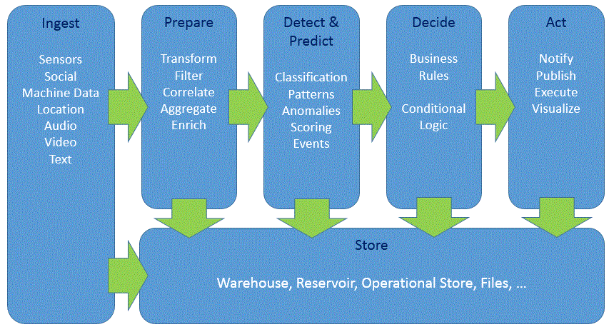

All Streams applications follow this basic pattern: ingest the data, filter/discard any uninteresting/erroneous data, analyze it and act on the results.

Each stage in the diagram above is handled by one or more operators.

For example, in the BusAlerts application:



**INGEST data from NextBus and the POIs from a file**

**DETECT when a bus is near the POI**

**Print the ALERT**

The bus data is *ingested*, buses near POIs are *detected*, and then the *alert* is sent.

## How to do it

To follow this pattern, you should build your application incrementally.

Instead of adding all the operators at once, **the best way to create your application is to do so in stages, starting small and progressively adding complexity.**

* Ingest the data and validate that the data you are working with is correct.
* Then, you can add operator(s) to further refine the data, with validation again as the last step.
* Add more complex analytics and logic
* Reporting, alerts and visualization.

So let’s start with the first step in your streaming application, which is acquiring data for processing.

## Acquiring input data

Since all Streams applications start with a data ingestion step, this is the first stage of your application.

If you do not yet have data to ingest, you can skip to the “generating sample data” section for a few tips on generating data for your application.

### Ingesting data using a source operator

The first step is to find the right source operator for your data.

The table below lists common data sources and the corresponding Streams operators.

View the full list of supported toolkits in the cloud and in a local install.

Supported toolkits on the IBM Cloud Streaming Analytics service [LINK]

<https://cloud.ibm.com/docs/apps/tutorials/tutorial_scratch.html#tutorial>

<https://cloud.ibm.com/docs/services/StreamingAnalytics/r_integrating_cloudant_rest.html#tutorials>

Supported toolkits on-prem [LINK] <https://www.ibm.com/support/knowledgecenter/SSCRJU_4.3.0/com.ibm.streams.toolkits.doc/spldoc/dita/toolkits/toolkits.html>

Where is my data coming from? File, HDFS, HBase, IoT devices, e.t.c.

|  |  |  |
| --- | --- | --- |
| Data source | Operator | Toolkit |
| Event Streams (formerly Message Hub) | MessageHubConsumer | streamsx.messagehub |
| MQTT | MQTTSource | streamsx.mqtt |
| Kafka | KafkaConsumer | streamsx.kafka |
| HDFS | HDFS2FileSource  HDFS2DirectoryScan | streamsx.hdfs |
| HBase | HBaseScan/HBaseGet | streamsx.hbase |
| Any JDBC compliant RDBMS | JDBCRun | streamsx.jdbc |
| JMS/XMS/ | JMSSource  XMSSource |  |

1B) Define the incoming data schema and use it with the source operator

Define the output schema that describes each incoming tuple:

e.g.

type XMLFromNextBus = xml xmlString;

type JsonFromKafka = rstring jsonString;

type DBRow = rstring id, rstring name, int32 id, timestamp last_seen;

1c) If your data is in a different format, such as JSON or XML string, or a binary blob, it will need to be converted to Streams tuples.

For example, if you have JSON data, use the JSONToTuple operator to convert it to SPL tuples. The XMLParse operator is used to convert XML data to tuples.

Step 1d) Verify the data is correct. Create a small application that ingests the data and then prints it to console or to a file:

Example 1: no parsing needed

//change this to match the tuples you expect

type RawDataType = int32 id, rstring name, rstring timestamp;

composite MyApp {

graph

stream<RawDataType> DataFromXYZ = XYZSource() {

}

**() as DataPrinter = Custom(DataFromXYZ as port0) {**

**logic**

**onTuple port0: {**

**printStringLn(“New Tuple : + (rstring)port0.id + port0.name”);**

**}**

**}**

The DataPrinter operator will almost always be more or less the same as shown above.

If you are not using the Streaming Analytics service and you have access to the local filesystem, you could also write the incoming data to a file using a FileSink and verify the ouput file’s contents.

Example 2

Adding a parsing step and using a FileSink

Generating data

* Use a Beacon to generate data: <https://github.com/IBMStreams/samples/blob/master/Examples-for-beginners/003_sink_at_work/sample/sink_at_work.spl#L16>
* More complex samples can be generated using a Custom operator:

<https://github.com/IBMStreams/samples/blob/master/Geospatial/MapViewerSample/com.ibm.streamsx.mapviewer/Main.spl#L27>

Helper functions defined here: https://github.com/IBMStreams/samples/blob/master/Geospatial/MapViewerSample/com.ibm.streamsx.mapviewer.gen/GeospatialGen.spl

## Where to find examples

* Samples for most toolkits are included in the toolkit repository in the samples folder.
* You can also search the Streams Samples catalog for examples. Click download zip to download the sample that you can import into Streams Studio, Atom or VSCode.
* Streamsdev also has articles and tutorials, search there.

# Troubleshooting

1. If submitting the job fails, you can view the full error in the Atom Console pane.
2. You receive the following error when opening the Streaming Analytics console in the browser:

CWOAU0062E: The OAuth service provider could not redirect the request because the redirect URI was not valid. Contact your system administrator to resolve the problem.

If this occurs, log in to the IBM Cloud Dashboard by visiting cloud.ibm.com. Then you can access the console through one of the following ways:

* + From the dashboard, click on your Streaming Analytics service instance under Services. Then from the instance page, click “Launch” to go to the console
  + In Atom, there is a direct link available from the Console pane. Look for *Streaming Analytics Console URL*.

1. Compiling an application fails with this message:

CDISP0127E ERROR: The following toolkit file is out of date: ../toolkits/com.ibm.streamsx.inet/toolkit.xml. This file is newer: ../toolkits/com.ibm.streamsx.inet/com.ibm.streamsx.inet/InetSource/InetSource.xml.

This error means a file in a toolkit you downloaded has changed.

1. If you did not make any changes, this might be a bug that you can work around by doing the following:
   1. Open a terminal window and change to the toolkits directory where you copied additional toolkits:

cd /Users/path/to/tkdir

* 1. For each toolkit listed in the error message, change to that toolkit directory.

cd com.ibm.streamsx.inet

touch toolkit.xml

Try recompiling your application again.

1. If you did try to change a downloaded toolkit, you need to recompile the toolkit itself before you can use it within your application. This requires you to download the Streams Quick Start edition for Docker. [LINK]. Once you have done so, you can find compilation instructions from the toolkit’s main page.

Note: You will need to download and compile the toolkit on the Quick Start Edition, then copy the compiled toolkit back to your local filesystem.